•        I used Codeception framework so at first, I installed it following the steps on its website (<http://www.codeception.com/install>)

**Details**

Codeception version: 2.4.6  
PHP Version: 5.6  
Operating System: Win 10  
Installation type: Phar  
List of installed packages (composer,Selenium,chrome driver)  
•    Suite configuration:

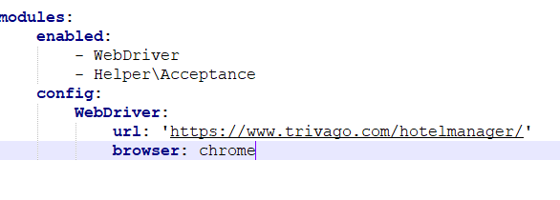

I used XAMPP and Git CMD to run PHP on my local. I changed config URL to https://www.trivago.com/hotelmanager in the acceptance.suite.yml file as well.

•       I decided to use WebDriver instead of PhpBrowser I wanted to see the results running an actual browser.

Selenium Standalone server needs to run

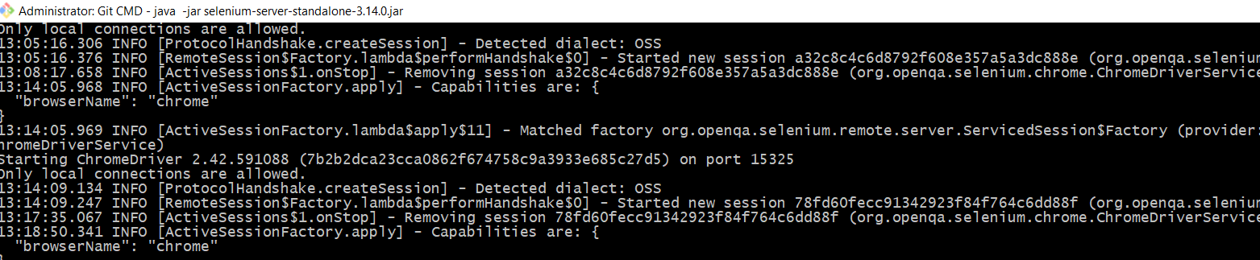

* This is the sample screenshot of LoginCest running test;

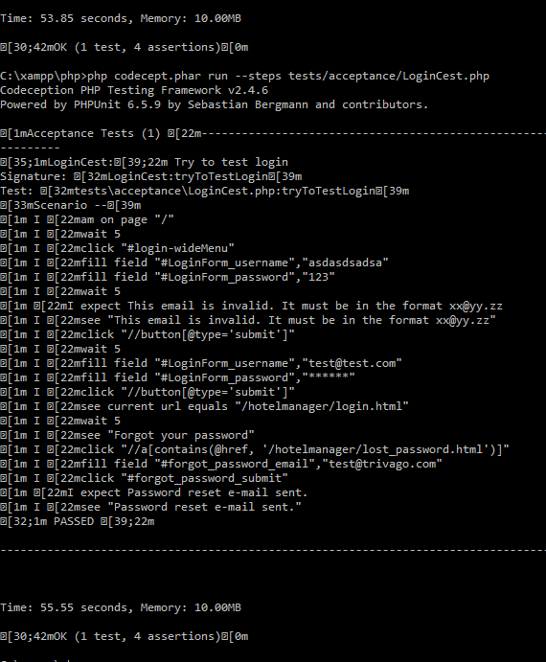

* This is the sample screenshots of RegisterCest running test;

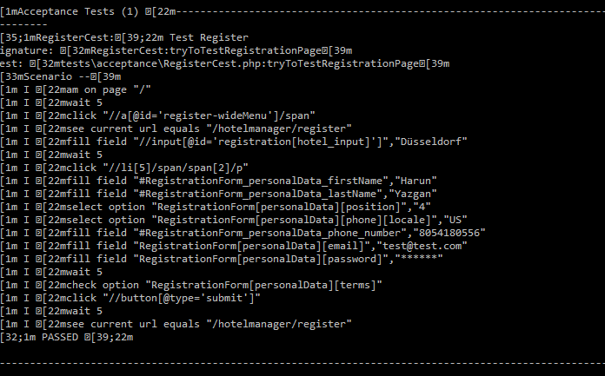

* This is the sample screenshots of ProCest running test;

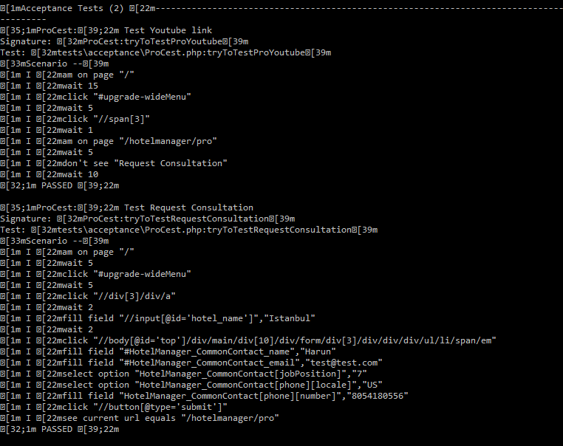

For creating a html report I used this command;

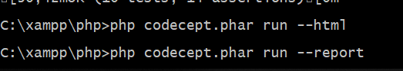

When I ran all cases at once I got more details as shown below;

You can see html report on the output folder as well;

